Performance measurement and analysis

Benchmarking
Benchmarking is the science of objectively assessing the performance of a system in comparison to other systems.
- Users: able to know which system is best suited to your needs.
- Engineers: able to make informed design decisions
Benchmarking is harder than it may initially appear…
The performance of a computer system is not just the frequency of the processor.
- A 4GHz Intel CPU is not the same as a 4GHz AMD CPU.
- Recall, the frequency of a processor indicates the number of clock cycles per second. The higher the frequency, the more clock cycles per second. But how much computation can be done per clock cycle? It depends on the system architecture.
An alternative to using processor frequency is to use Millions of Instructions Per Second (MIPS) instead.
- However, MIPS doesn’t factor in the complexity of the instructions being executed.
- Some instructions do more computation than others.
- Some architectures allow for complex instructions, others stick to reduced instructions (RISC vs CISC)
Take for example this instruction set from RISC:
LOAD(X, R₁)
LOAD(Y, R₂)
MULT(R1, R₂)
STOR(Z)
This can be simplified in CISC:
MULT(X, Y, Z)
They’re capable of performing the same computation, but it would appear that the RISC architecture is better at face value, since it has more instructions.
Floating-Point Operations Per Second (FLOPS) is another measure that attempts to capture the performance of a computer system.
- However, there is no consensus on what a floating-point operation is!
- To capture multiplication, we’ve seen a system will:
  - Split the multiplication into partial products
  - Bit shift
  - Add the results of the partial products
- So is multiplication one operation? Or are the sub-steps separate operations?
A different approach may be to take how long a computer system takes to run a program. It’s a simplistic way at face value, but there can be other considerations such as:
- Time
- Price
- Hardware usage
People don’t generally buy new computers to do one particular program. Take video games. Here, we take the performance as the game is running.
To summarise:
- What is your benchmark? e.g. Python script, video game, synthetic benchmark
- What will you measure? e.g. Execution time, frames per second, memory use, clock rate, MIPS, FLOPS
- What are your other considerations? e.g. Financial cost, running expenses, size

Benchmark examples
- MacOS and Windows: NovaBench
- Linux: sysbench cpu run
  - Close other applications first to get a fair benchmark!
Primes identification is one example of synthetic benchmark.
- Famous (historic) examples of synthetic benchmarks:
  - Whetstone: Trigonomic and exponential functions
  - Linpack: Linear equations and double precision arithmetic
  - Dhrystone: String manipulations and integer operations
- Single synthetic benchmarks are easy to optimise to!
  - They do not provide an “honest” measure of a system’s performance at general computing.
Benchmark suites are advantageous to single synthetic bencharks because:
- They are harder to optimise to
- Potentially more representative of general computing patterns
- New benchmarks can easily be swapped in or out
  - The historic synthetic benchmarks are trivial for modern hardware nowadays!
Standard Performance Evaluation Corporation (SPEC) has probably the most widely used benchmark suite.
- It contains several programs for a wide range of integer and floating-point operations, arranged into two sets.
  - CINT2017 set of programs for integer operations
  - CFP2017 set of programs for floating-point operations
- This suite is updated with computing trends.
  - Attempts to capture “general modern computing”. You may also see CINT/CFP2000 and CINT/CFP2006 results reported.

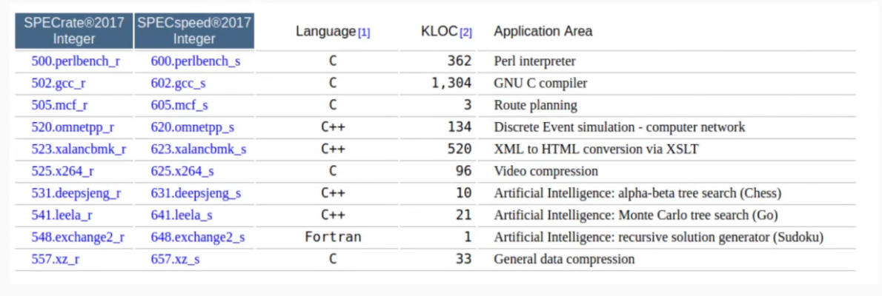
CINT2017

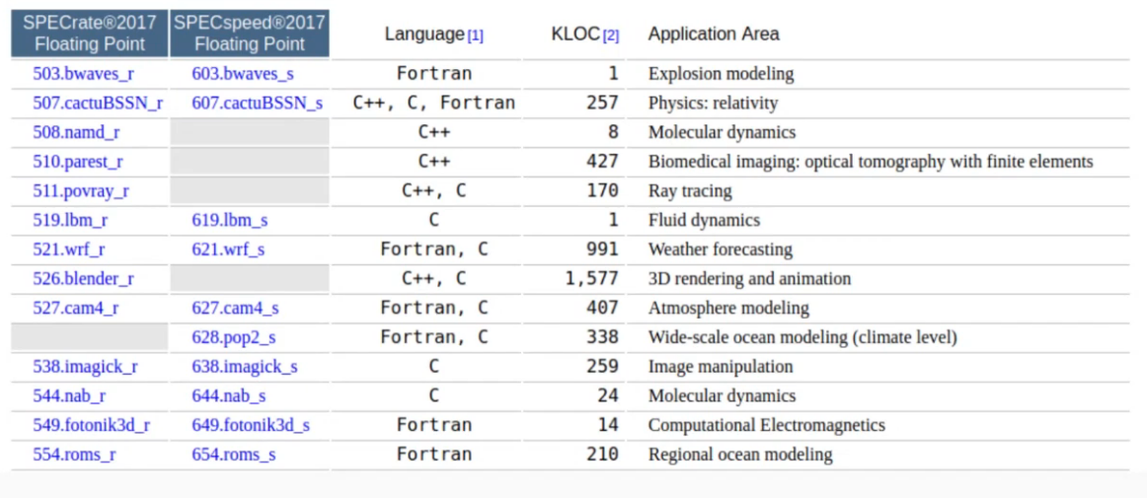
CFP2017

The final result is the gemoetric mean of the run times for each program in the suite.
- The geometric mean of the set of numbers {a₁, a₂, …, a_{n}} is:


- Why geometric mean?
  - Times for each program are different scales, so geometric mean is more appropriate.

Consider the benchmark suite:
Computer Time taken Arithmetic mean Geometric mean
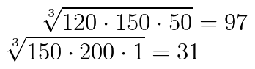
1. [150, 200, 1] 117
2. [120 150, 50] 110

CPU Optimisation
If our system is CPU bound then CPU optimisation may be necessary to improve system performance.
We will look at the following ways to achieve this:
- Picking the correct ISA: RISC or CISC?
- Branch optimisation: avoiding hazards of pipelining
- Code optimisations: what to do better at the software level
The two main kinds of instruction sets in von Neumann systems are:
- Reduced Instruction Set Computers (RISC)
- Complex Instruction Set Computers (CISC)
Recall:
- Execution cycles = clock cycles per instruction x number of instructions.
Each try to reduce the length of time a program takes to execute:
- RISC shorten execution time by reeducing the clock cycles per instruction.
- CISC improve performance by reducing the number of instructions per program.

In RISC:
- A few, simple instructions, fixed in length
  - Control units can be hardwired for maximum speeds
  - Instructions take 1 cycle to process –> easier pipelining!
  - Programming is more arduous, requires more instructions for complex operations.
- Only Load/Store instruction for memory access with few addressing modes.
  - Paramter passing through registers –> fast sequential execution.
  - Requires more (expensive) registers.
In CISC:
- Many complex instructions, variable in length
  - Control units need to use special circuits for interpreting instructions as they are fetched from memory. This can take additional time.
  - Instructions may take multiple/variable numbers of cycles to process
–> harder to manage pipelines
  - Easier to program, fewer instructions required for complex operations.
- Many instructions can access memory, many addressing modes.
  - Parameter passing through memory
–> additional strain on von Neumann bottleneck.
  - Fewer registers needed, fewer operands per instruction
So which is optimal?
- The first digital computers were RISC due to having simple programs anyway.
- As programs became more complex (80s – 90s), CISC systems became dominant. PCs still commonly use CISC processors (e.g. Intel x86, AMD).
- RISC processers used in some PCs (e.g. ARM), phones, tablets, embedded systems.
- Modern CISC processors (Intel, AMD) breakdown complex instructions into series of simpler ones to be executed (effectively executing instructions that are of RISC-level complexity).
  - Sometimes this allows them to be pipelined more easily
  - But it requires more space on the chip, more power, and produces additional heat.
See Apple Silicon!

Branch Optimisations and Code Optimisations
Pipelines offer significant speed up if the pipeline can be kept full.
However, hazards like branch instructions can result in flushing the pipeline.
1 instr A
2 instr B
3 if COND
4 instr C
5 instr D
6 else
7 instr E
8 instr F
9 instr G
10 instr H
- When executing instr B, which instruction should we be fetching? Should we fetch C or E? We could wait until instr B completes, executing before fetching the next instruction, but this has a time cost.
- Delayed branching: fetch instructions after the conditional.
  - We could fetch instr G. The compiler needs to check this doesn’t breach data dependencies; does instr G depends on the instruction inside the conditional?
- Branch prediction: speculatively fetch the next instruction from one of the branches.
  - We could fetch instr C or instr E
  - There is a penalty for predicintg wrong: instruction (and data) has to be removed from registers). So how do we predict the correct branch?
    - Pick randomly:
      - For two branches this is correct 50% of the time. May be net-positive if penalty for predicting wrong is not too high.
    - Static prediction:
      - Analyse the code at compile-time, like assume backwards branching on loops. Correct 80% of the time (SPEC analysis)
    - Dynamic prediction:
      - During run-time, keep track of how often each branch is taken. When the conditional is encountered in future, fetch the most common branch. This needs some training time to warm up.
Sometimes the greatest optimisations can be made at the software level: by optimising your code in a way that suits the CPU its going to be run on.
- Use appropriate data types
  - Dont use a double when an int will do.
- Eliminate unnecessary branches
  - Minimise the number of branches by combining conditions.
  - Remove branches that will never execute
- Use multiplication instead of division
  - As we’ve seen, multiplication is a simpler computation.
- Profile your program
  - Identify parts of your program that are using the most processor time.
In modern, high-level- compiled languages (e.g. Java), the compiler will do a lot of the low-level optimisations for us.
- This alleviates the programmer from having to focus on optimisation all the time, so they can focus on other virtues (e.g. readability).
  - Program optimisation is still a problem for compiler design!
- Attempted optimisations can actually be detrimental.
  - Often the best way to optimise your code is to give your compiler as much information as possible, rather than try to optimise it yourself!
  - The vast majority of the time the compiler will be better at optimising your code than you
- As a programmer, you need to know when and how to optimise your code approrpiately.
  - Typically this will be high-level algorithm decisions.

Memory optimisation
Speeding up the CPU is only going to improve performance if the system is CPU bound.
But performance may be bound by other components such as memory
- This is especially true for von Neumann architectures (von Neumann bottleneck!)
So how can we optimise a system’s memory to improve performance?
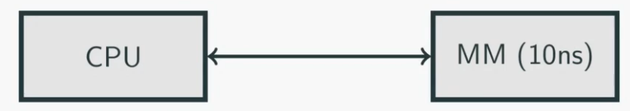

10ns may be too slow, so we may use a cache
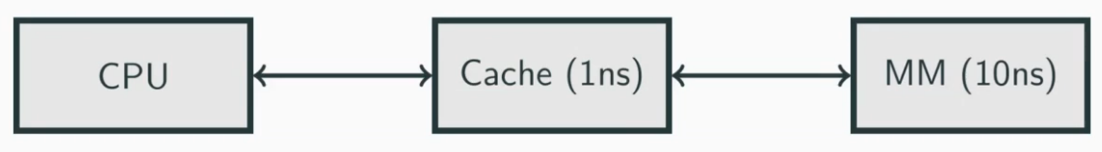

Introducing a cache, with faster access times but smaller capacity to store some data.
- How do we decide what data to store in the cache?
  - Pre-fetching based on usage patterns
  - Prone to cache pollution if we get it wrong.
- If data in the cache is changed, when to write back to main memory?
  - Cache is volatile memory, in case of system power off data in the cache is lost
  - Write-through or write-back policies.
Memory access typically follows usage patterns.
- Temporal locality: If a location has been accessed recently it is likely to be accessed again.
  - e.g. Accessing the top of a stack.
- Spatial locality: If a location has been accessed recently, it is likely that nearby locations will be accessed in the near future.
  - e.g. Loops, arrays.
- Sequential locality: If an address has been accessed recently the next/previous location is likely to be accessed next.
  - e.g. Instructions.

Write-through cache
- Whenver data in the cache is changed, simultaneously write it to main memory
- Imrpves reliability, but reduces performance.
Write-back cache
- Wait until an efficient point in time to write unchanged cache data to main memory.
- When a read operation occurs for main memory, the write operation(s) can be ‘piggy-backed’ onto it.
- Improves performance for write operations, reduces performance for read operations, reduces reliability.

